Title: Validation of Portrayal Inputs

S-100 Maintenance - Change Proposal Form

|  |  |  |  |
| --- | --- | --- | --- |
| **Organisation** | NIWC | **Date** | 11/24/2021 |
| **Contact** | David Grant | **Email** | david.m.grant22.civ@us.navy.mil |

Change Proposal Type *(Select only one option)*

|  |  |  |
| --- | --- | --- |
| 1.Clarification | 2.Correction | 3.Extension |
|  |  | X |

Location (*Identify all change proposal locations)*

|  |  |  |  |
| --- | --- | --- | --- |
| S-100 Version No. | Part No. | Section No. | Proposal Summary |
| 5.0 Draft redline | 9  XSLTPR Schema | 9-10  Figure 9-20  9-13.3.22  S100PortrayalCatalog.xsd | Adds 9-10.1 Portrayal Input Validation  Update UML for schema changes  Update ContextParameter, add new types  Update schema |

Change Proposal

Attached.

Change Proposal Justification

Product and OEM support for this extension is optional, but where supported:

* Supports standards compliant validation of inputs to S-100 portrayal rules.

- Provides a performant, simple implementation supporting best practices for cyber-security

* Enhances portrayal robustness

* Enhances security

- Enhances resistance to code-injection attacks

What parts of the S-100 Infrastructure will this proposal affect?

S-100 Feature Concept Dictionary Interface or Database

S-100 Portrayal Register

S-100 Feature Catalogue Builder

S-100 Portrayal Catalogue Builder

S-100 UML Models

S-100 GitHub Schemas

**Please send completed forms and supporting documentation to the secretary S-100WG.**

# Portrayal processing

[No change]

## Portrayal Input Validation

The portrayal catalogue describes each valid portrayal input parameter (context parameter) and may provide associated validation rules and value constraints. The validation rules are XPath 1.0 boolean expressions or W3C XML Standard Part 2 Appendix F regular expressions. The rules support validation of the user input to portrayal, and the constraints support eliminating free-form input while supporting a machine-readable user interface (UI).

To ensure user-entered values are reasonable prior to use as portrayal input, the validation rules may:

* Ensure input values are within the expected value domain
* Ensure input values conform to an expected pattern (e.g., ###-####)
* Ensure input values are logically consistent with respect to one another

Additionally, context parameters and validation rules can be enabled or disabled based on XPath 1.0 boolean expressions, supporting conditional validation and a machine-readable UI. For instance, validation of the S-101 Shallow Contour parameter may be disabled when the value of the Two Shades parameter is true.

Context parameters with an associated constraint are restricted to a set of enumerated values. This allows applications to eliminate free-form input for these parameters, and enhances the machine-readable UI by associating a label with each enumerated value (e.g., „On“ associated with the value „1“).

Applications support portrayal input validation by:

1. Using the constraints to restrict user input.
2. On each change to a context parameter value:
   1. Generate a simple XML document encoding the context parameter values:

<TwoShades>true</TwoShades> <!-- etc.-->

* 1. For each enabled validation of each enabled context parameter:
     1. Ensure XPath rules evaluate to true
     2. Ensure regular expressions match

XPath validations should all evaluate to true, and regex validations should all match prior to processing the portrayal rules. If an enabled validation evaluates to false or doesn’t match then no further portrayal processing should be performed, and error messages associated with failed validation rules should be activated.

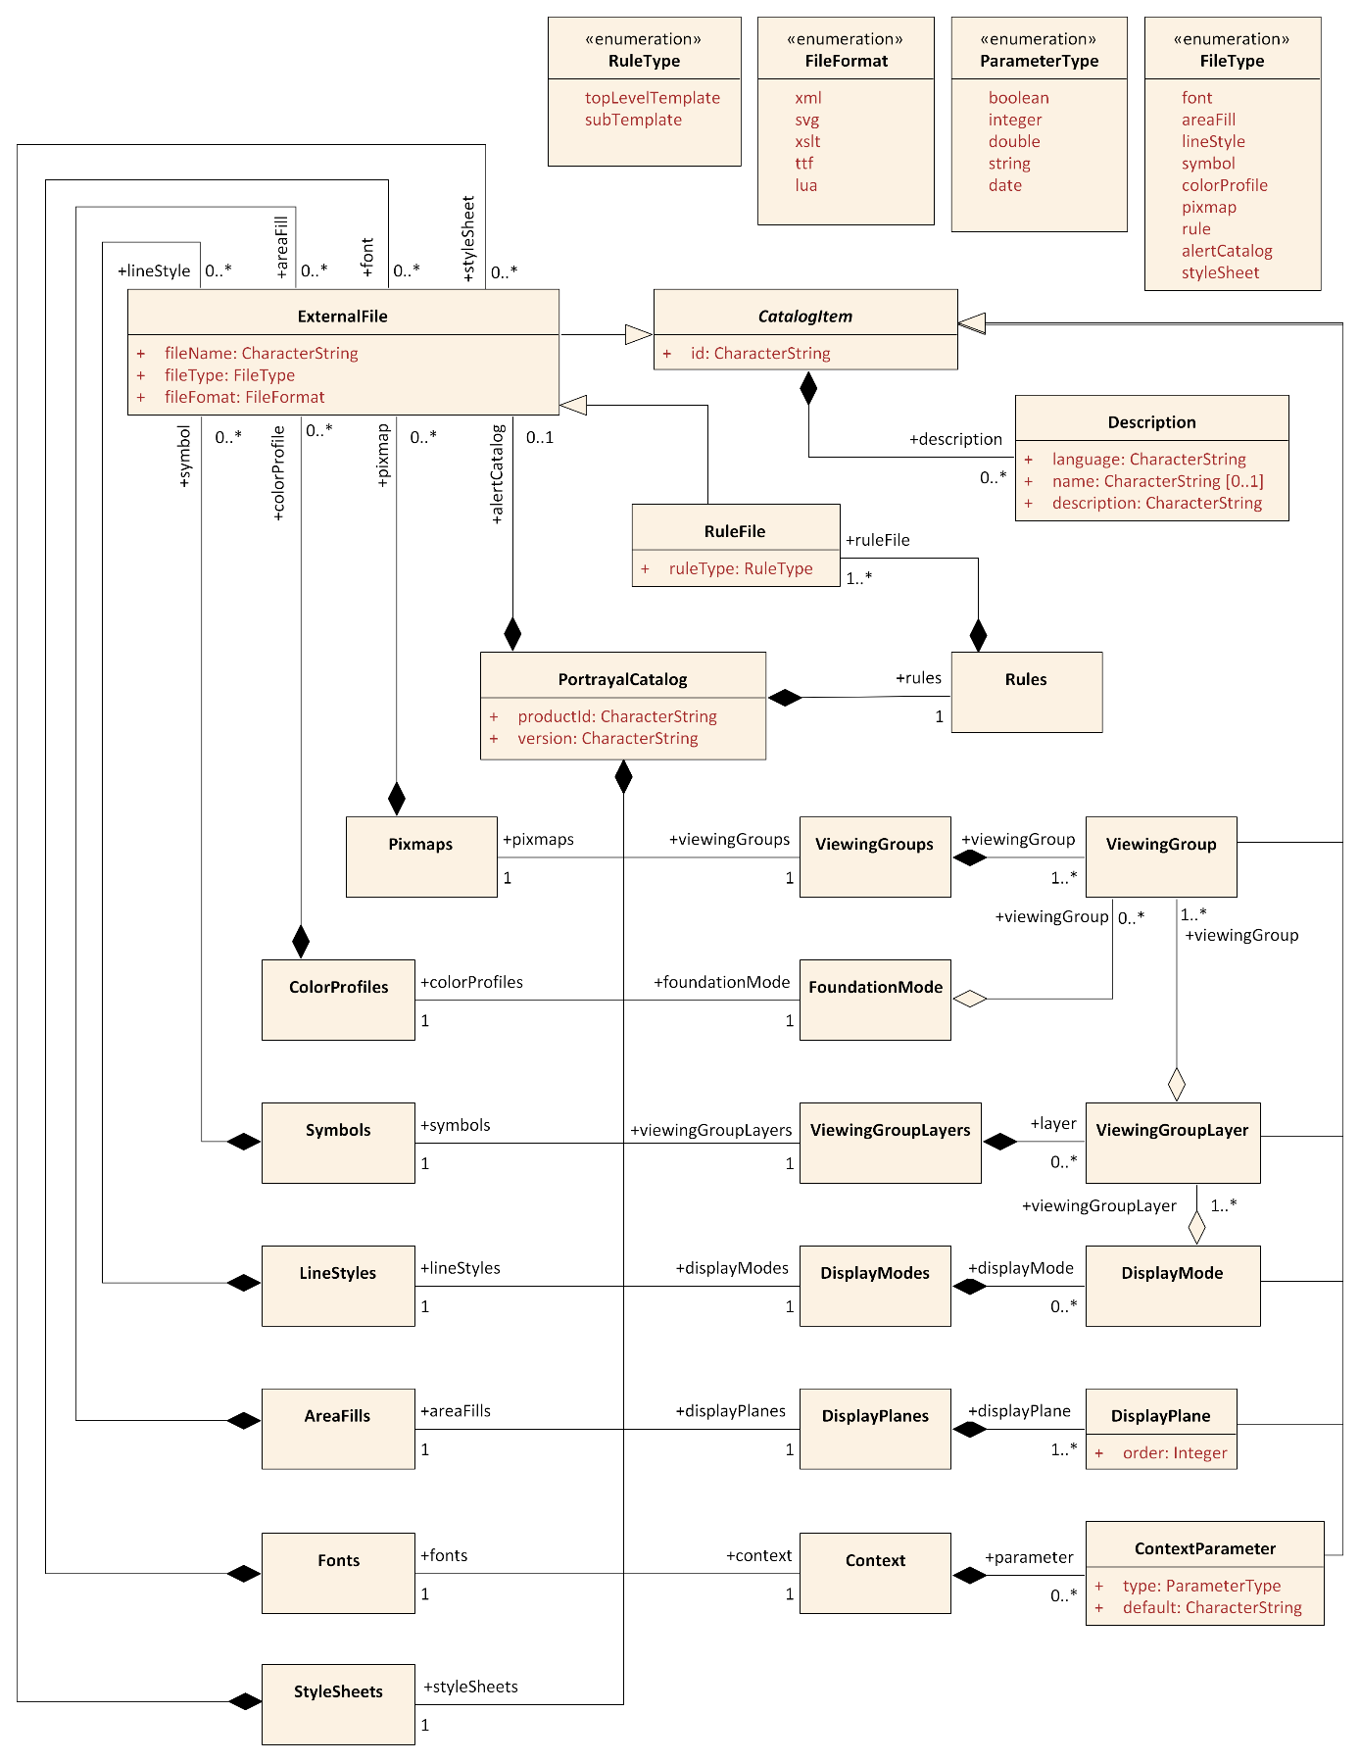

Figure 9-20 — Catalogue

### ContextParameter

| **Role Name** | **Name** | **Description** | **Mult.** | **Type** |
| --- | --- | --- | --- | --- |
| Class | ContextParameter | A Context Parameter name and definition | - | - |
| Subtype of | CatalogItem | See CatalogItem | - | - |
| Attribute | type | The data type of the Parameter | 1 | ParameterType |
| Attribute | default | A default value for the Parameter | 1 | string |
| Role | constrain | Constrains the value domain of the parameter. | 0..1 | ConstraintType |
| Role | validate | The validation rules for this parameter. | 0..* | ValidationType |
| Attribute | enable | XPath 1.0 boolean expression. Used to indicate conditional parameters (e.g, ShallowContour is conditional on TwoShades: „//TwoShades=false“) | 0..1 | string |

### ConstraintType

| **Role Name** | **Name** | **Description** | **Mult.** | **Type** |
| --- | --- | --- | --- | --- |
| Class | ConstraintType | Constrains the allowed values of a context parameter and provides meaningful names for enumerations. | - | - |
| Role | enumeration | Valid values and labels of the constraint. | 1..* | EnumerationType |

### EnumerationType

| **Role Name** | **Name** | **Description** | **Mult.** | **Type** |
| --- | --- | --- | --- | --- |
| Class | EnumerationType | Represents an enumerated value. | - | - |
| Role | label | A label for the value (e.g., „Enabled“) | 1..* | TextType |
| Attribute | value | The value of the enumeration (e.g., „1“) | 1 | string |
| Attribute | icon | An icon representing the value. Reference to a catalog symbol. | 0..1 | string |

### TextType

| **Role Name** | **Name** | **Description** | **Mult.** | **Type** |
| --- | --- | --- | --- | --- |
| Class | TextType | Adds an optional language attribute to a string. | - | - |
| Attribute | - | String value in a national language. | 1 | string |
| Attribute | language | An ISO 639-2/T alpha-3 language identifier code indicating the national language of the encoded string. Default is „eng“. | 0..1 | string |

### ValidationType

| **Role Name** | **Name** | **Description** | **Mult.** | **Type** |
| --- | --- | --- | --- | --- |
| Class | ValidationType | Class for a validation rule. Either xpath or regex must be present, but not both. | - | - |
| Attribute | xpath | An XPath 1.0 boolean expression. | 0..1 | string |
| Attribute | regex | A regular expression per W3C XML Standard Part 2 Appendix F (Regular Expressions) | 0..1 | string |
| Role | errorMessage | An error message for the validation. | 1 | ValidationErrorType |
| Attribute | enable | XPath 1.0 boolean expression. Indicates conditional validation (e.g., validate NationalLanguage only when populated: „//NationalLanguage[.!=‘‘]). | 0..1 | string |

### ValidationErrorType

| **Role Name** | **Name** | **Description** | **Mult.** | **Type** |
| --- | --- | --- | --- | --- |
| Class | ValidationErrorType | Class for a validation error. | - | - |
| Role | text | Text of an error message in one or more national languages. | 1..* | TextType |
| Attribute | icon | An icon representing the error. Reference to a catalog symbol. | 0..1 | string |

S100PortrayalCatalog.xsd

